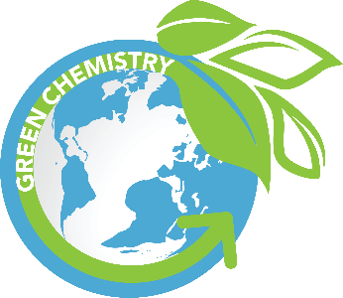**The 12 Principles of Green Chemistry**

The 12 Principles of Green Chemistry, also known as sustainable chemistry, aim to reduce or eliminate hazardous substances in the design, manufacturing, and use of chemical products.

**1. Prevention:** Avoid waste production rather than cleaning it up after it’s formed.

**2. Atom Economy:** Maximize incorporating all materials into the final product.

**3. Less Hazardous Chemical Syntheses:** Use and generate substances that are not toxic or harmful to human health and the environment.

**4. Designing Safer Chemicals:** Chemical products should be designed to have little or no toxicity while maintaining efficacy.

**5. Safer Solvents and Auxiliaries:** Minimize the use of auxiliary substances like solvents or ensure they are non-toxic and sustainable.

**6. Design for Energy Efficiency:** Reduce the energy required for chemical processes and perform reactions at ambient temperature and pressure whenever possible.

**7. Use of Renewable Feedstocks:** Prefer raw materials that are renewable rather than depletable.

**8. Reduce Derivatives:** Minimise or avoid unnecessary chemical modifications during a reaction.

**9. Catalysis:** Increase efficiency using catalytic reagents instead of stoichiometric ones.

**10. Design for Degradation:** Chemical products should be designed to break down into harmless substances after use, preventing environmental pollution.

**11. Real-Time Analysis for Pollution Prevention:** Monitor real-time processes to prevent hazardous substance formation.

**12. Inherently Safer Chemistry for Accident Prevention:** Minimize the potential for chemical accidents, including explosions, fires, and releases of toxic substances.

**Further Reading:**

Pearson 12.1 Green Chemistry.